SCHOOL OF ELECTRONIC AND ELECTRICAL ENGINEERING



EE3A1
Computer Hardware and Digital Design
Assignment Report

Student Name: Ying Deng
Student ID: 1205690
Subject: Electronic engineering with business management
Lecturer: Dr Steven Quigley

Contents:

Abstract
Basic information of the assignment
Introduction about the assignment
Assignment designing details
Simulation results
Conclusion
References

Appendix:
- VHDL code of the assignment
- Simulation Outputs
- Individual requirements from the assignment guide and result check

Abstract
This experiment is held after the lectures of the computer hardware and digital design. During the lecture, we learned the general ideas of hardware designing theories, such as using VHDL language to design hardware solutions for complex digital systems, data hazard and its avoidance, pipeline for better efficiency in the systems. The techniques of VHDL programming are very important in terms of computer hardware designing.

Basic information of the assignment
Software: Aldec Active-HDL 8.2
Programming language: VHDL
Location: GK-206
Assignment date: 8th, September, 2012, Monday-18th November, 2012, Sunday
Date of Report: 15th, December, 2012, Saturday

Introduction
This assignment has four lab sessions, to create a RISC microprocessor with basic functions for calculation and data processing, and also some basic techniques to enhance accuracy and

The aims of this assignment are to experience the software system used when designing digital systems, to obtain a general understanding of the effect of system data hazards, hence understand various characteristics about digital systems and of pipelining. In order to complete this assignment and observe the output of the system according to specific input, I used the simulation of the software to observe the waveforms.

This lab report follows step-by-step designing process to achieve the final target. The sequence of the designing process is:
ALU—ROM--Register—Clock Enable--Op-code Check--Pipeline—Data hazard elimination.
There will be a clear demonstration of the aimed output for each steps. The data hazard was not considered until the end of the designing process, so in the early outputs the time sequence of the system have certain delay/mistake that could be eliminated in the last step.

The experiment uses only the software simulation for testing, so there might be errors in the real world system caused by the initial value of the circuit. A safe mode and other necessary steps will be needed for a more stable and reliable system.

Details of design
The following picture shows the overall structure of the system.
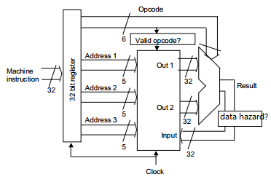
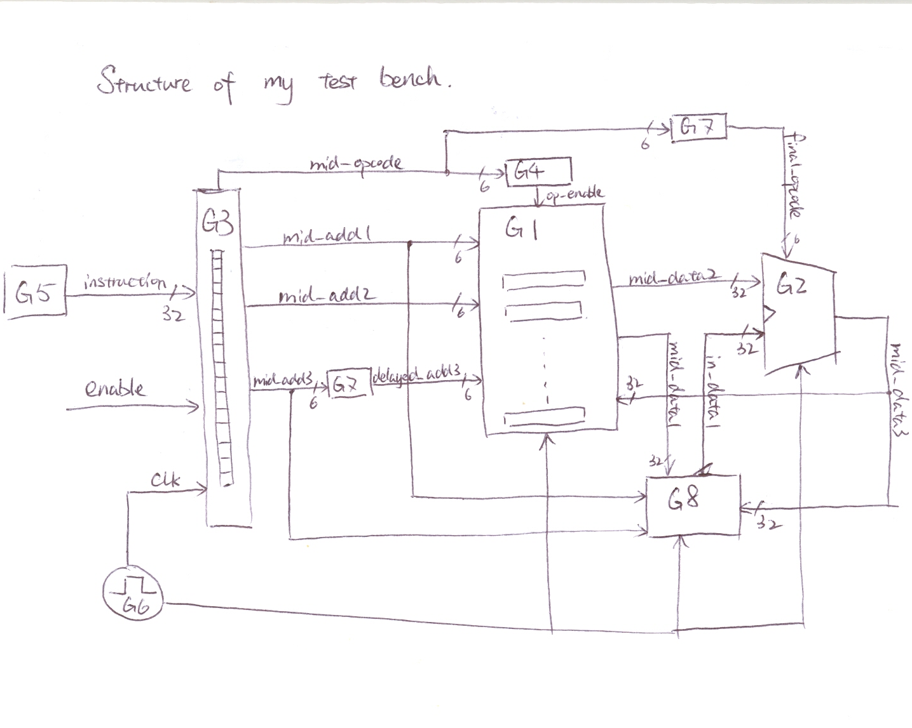
G represent the “g1”-“g8” in the test bench source code. Please see Appendix 1 for details.
There are some adjustments to the provided diagram in order to avoid data hazards. This will be described later.

- The following sentences describe the system by each block.
ALU: It is an ordinary ALU that has two input of data and one input of op-code and one output of data. The lengths of data are 32 bits and the length of op-code is 6 bits. It has 10 different functions, which is decided by the input op-code, expressed in a WHEN-ELSE structure.

ROM: It is similar to the ROM in the handout, with 32 data stored inside. It can be rewritten by changing the third input of it, expressed as “indata”. It is also controlled by the clock and the op-code-enable input. So it only works when there is a rising edge of the clock and when the checked op-code is a valid one. Effort was made to avoid undefined output of “XXXXX”.

Register: This register acts as a splitter that splits the input to op-code and addresses for ROM’s input. The last 8 digits of data are not useful and are dumped when outputting to the ROM. It is also controlled by the clock and only work on the rising edge of the clock. The following chart shows how the instruction is divided into different inputs to the ROM:
op-code |  |  |  |  |  | 1st address |  |  |  |  |  | 2nd address |  |  |  |  |  | 3rd address |  |  |  | unused
31 | 30 | 29 | 28 | 27 | 26 | 25 | 24 | 23 | 22 | 21 | 20 | 19 | 18 | 17 | 16 | 15 | 14 | 13 | 12 | 11 | 10 | 9 | 8 | 7-0

Op-code-check: This is a small block added after the above blocks are tested. It inputs the op-code split by the register and checks its validity. If it is valid, the block outputs the op-code to the ROM, instead of the initial process of register outputting directly to the ROM. If the op-code is invalid, it disables the ROM and the ROM’s output will remain as last clock circle.

Delay: As my op-code-check block is not controlled by the clock, it needs one clock-circle delay to be synchronized with the input data. Also the data into address 3 should be one clock-circle later than corresponding address 1 and 2. This block adds one clock-circle delay to this two signals in order to get the correct time sequence of data.

Pipeline: This block stores all the input data into the system, and sends them one-by-one on each rising edge of the clock. It acts as a pipeline structure that simplifies and accelerates the processing speed of the system.

Test bench: This block connects all the separate blocks together, by adding signals between each block. It also defines the clock frequency, and adds a gate to eliminate time hazard. The method of hazard elimination will be discussed in the following paragraphs.

- The following description is based on data flowing sequence:
The best way to describe the sequence would be the execution pipeline. The system can be divided into 4 steps:
Instruction fetch (IF), Operand fetch (OF), Execution (EX), Write back (WB)
The following picture shows the 4 stage in this system.
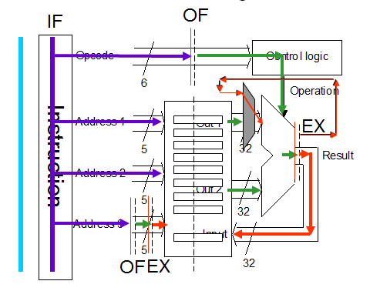
Clock cycles of execution pipeline:
In the real life hardware would be very expensive and complicated to manufacture, so the assignment requires that all parts of the design that are synchronized to the clock should use only the rising edge of the clock. So that means each parts only can act once in each clock cycle. As assignment suggested, one of the main challenges in this design is figuring out on which clock cycle inputs should arrive, and outputs should become valid.

To make it clearer, the following list shows the sequence of signal entering each block.
There will be 5 instructions: Instruction A, B, C, D, E, entering the system one at a time at the rising edge of clock;
There will be 8 signals: op-code(into the ALU), address1-3, data1-2, result(data3) for each clock cycle, and each instruction gives different values of these signals.
The idea is: representing those 8 signals according to their instruction, for example instruction A gives address 1 the value of add-A.
There are registers in the Register block and ROM block, And in order to synchronize, there are added delays to the address3 input and Op-code-check blcok. This means one-clock-cycle delay between these blocks’ input and output.
To illustrate, the data being re-written into the ROM is shown, called data3.

Clock cycle | Input | Op-code | Address 1&2 | Address 3 | Data 1&2 | Data 3 | Result(Writeback)
1 | A | ? | ? | ? | ? | ? | ?
2 | B | ? | Add-A | ? | ? | ? | ?
3 | C | Op-A | Add-B | Add-A | Data-A | ? | Res-A
4 | D | Op-B | Add-C | Add-B | Data-B | Data-A | Res-B
5 | E | Op-C | Add-D | Add-C | Data-C | Data-B | Res-C

It can be clearly seen that there are 2 clock-cycle of delay between the output result and the input instruction. What’s more, there will be 1 clock-cycle of delay between the called address 1&2, and the input address 3.

Further enhancements to the system:
- Time hazard and its elimination:
This system has one clock-circle of delay time before the output data is actually stored into the ROM and ready to use. This means there is the possibility of one clock-circle of time hazard that the second input requires the first output’s data while the data is not ready to be used, to be more clearer, when the used data’s address is same with the feedback data’s address (address1 = address3. See Appendix 1-ALU for information on address definitions). There are hardware and software solutions to this problem and Active-HDL and show the results of software solutions. The software solution of time hazard has two directions: adding no-ops between outputs and inputs, or add an extra feedback path that does not introduce clock-related delays. The gate 9 of my design adopts the first method, and the gate 8 of it adopts the second. As the no-ops method will introduce an extra delay to the output, which means doubling the process time if the hazard appears (see Appendix 2 for simulation waveforms), I have chosen the second solution to give simulation outputs. The comparison of processing time for the two methods is: 33 cycle compared to 62 cycles (for no-ops).

- Signed/Unsigned problem:
In the designing process I discovered that in the ROM block signed signal is necessary, while the op-code signal requires unsigned signal because it needs all 5 bits to record the op-code from 0 to 31. This raises the problem of constant change in signed/unsigned and confusion and also the possibility of data overflow in operations. So I actually changed the bit-length of op-code so that all the signals can be signed. This has the problem of longer instruction signals. It can be shorten by only using 5 bits of op-code, but in this case, the ROM should be changed into using unsigned library, and so is the test bench block.

Simulation results
Student ID: 1205690
Final result: FFFE8727(HEX). Please see Appendix 2& 3 to have more details.
Number of clock cycles to have final result: 33. Please see Appendix 2 to have more details. Note: There are 29 instructions in the test bench.
Intermediate results: updates every 1 clock cycle. Please see Appendix 3 to have the results.
Number of clock cycles to have intermediate result: 3. Please see Appendix 2 to have more details.

The final edition of the code gives good and clear output as required, data updates at every clock circle, and the initial delay is 3 clock circles. After finishing all the input instructions, it stops the operation and the ROM’s data in address 1F( decimal 0031) is the aimed output for the assignment. (It can also be set to work continuously by deleting the “WAIT;” sentence in the pipeline block.)
Conclusion
During accomplishing this assignment, I have learnt things such as: using VHDL to build a digital system, using VHDL libraries properly, being careful with grammars and forms of the language, properly splitting the project into different source file for easy understanding and editing, methods to avoid time hazard, skills to test the system, etc.
This assignment helps me combining all the aspects of the language into a whole, and I began to understand how each part of the code communicate and link. I also learnt how powerful VHDL is when we need to deal with complex digital systems and how it can save time and effort for designing.

References
1. EE3A Lecture Handout (lecture 1-14)
2. EE3A Assignment Guide Part 1&2

[Online material]
1. Wikipedia
2. zhidao.baidu.com (Chinese)
3. translate.google.co.uk/
4. Peter J. Ashenden, The VHDL Cookbook (First Edition), Dept. Computer Science, University of Adelaide, 1990, Ch 2&4

Appendix 1. VHDL SOURCE CODE
a) Test bench-1
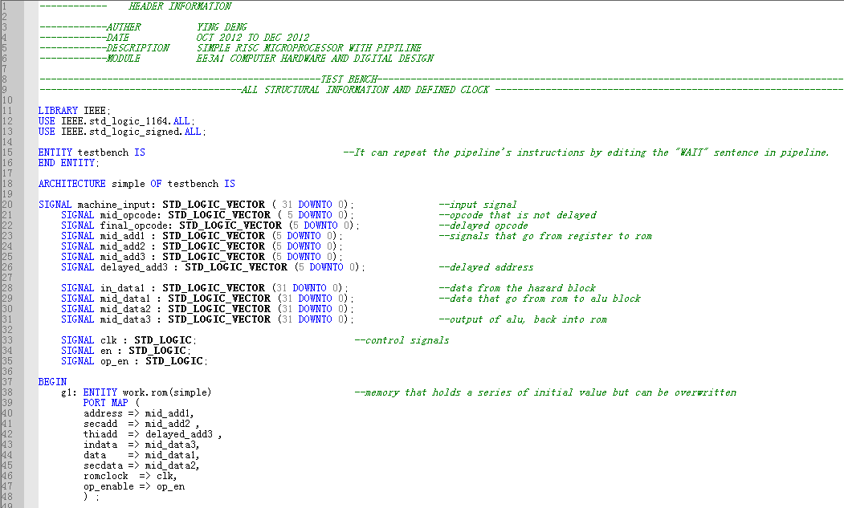
Test Bench-2
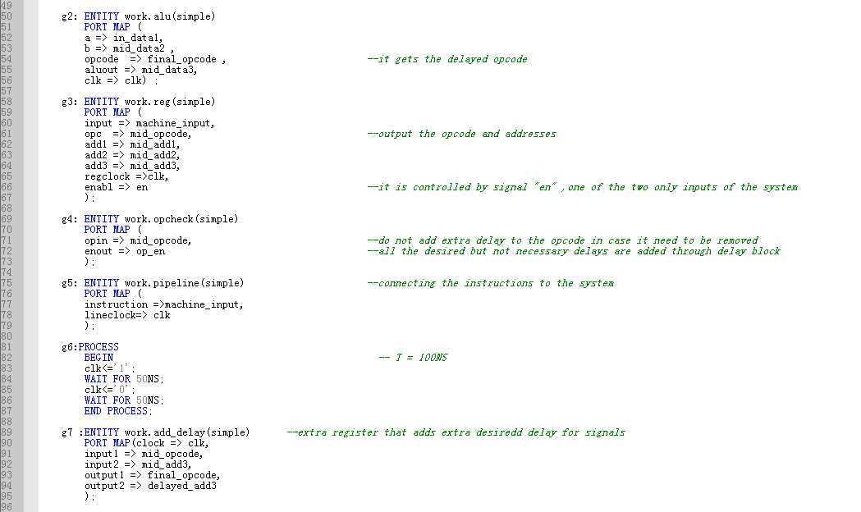
Test Bench-3
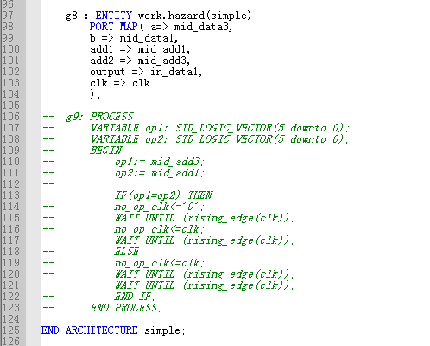

b) ROM
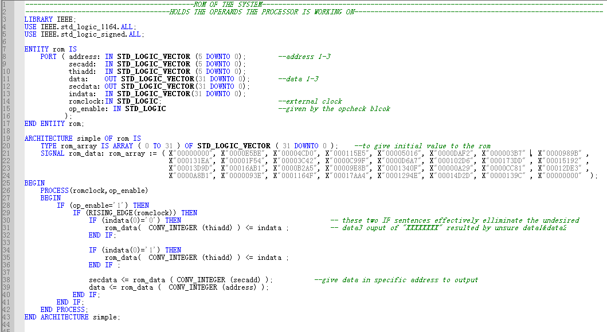
c) ALU
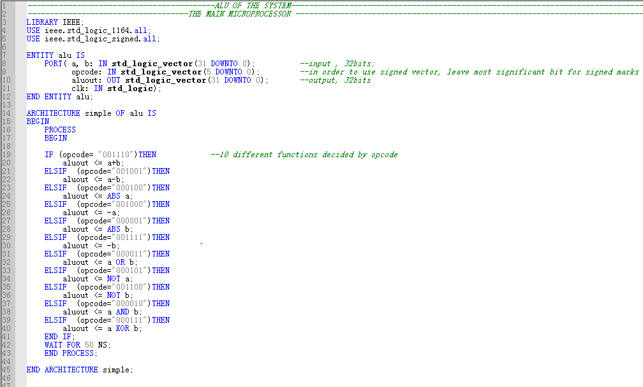
d) Register
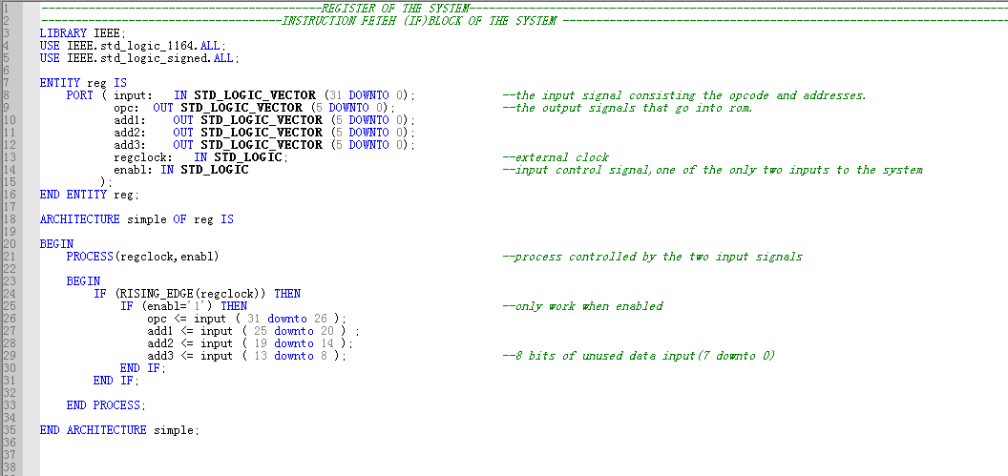
e) Op-code check-1
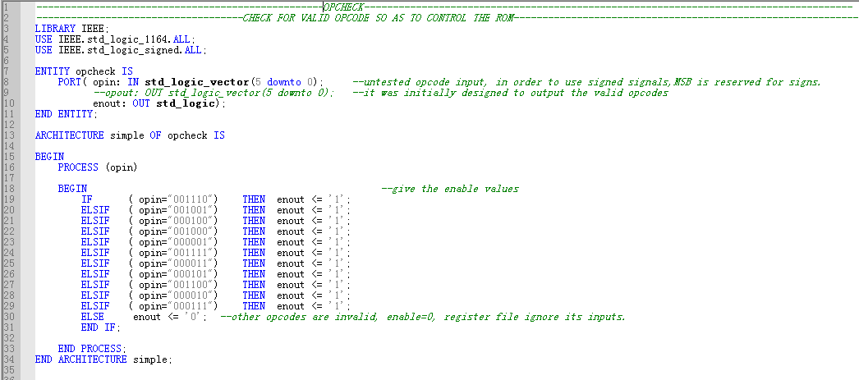

f) Hazard
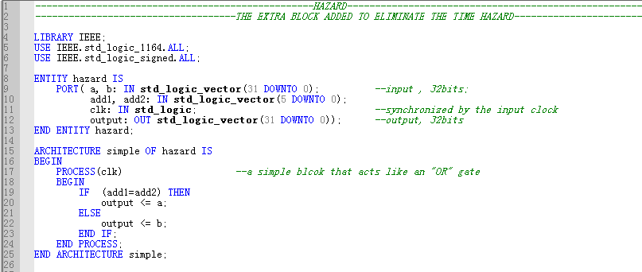

g) Pipeline-1
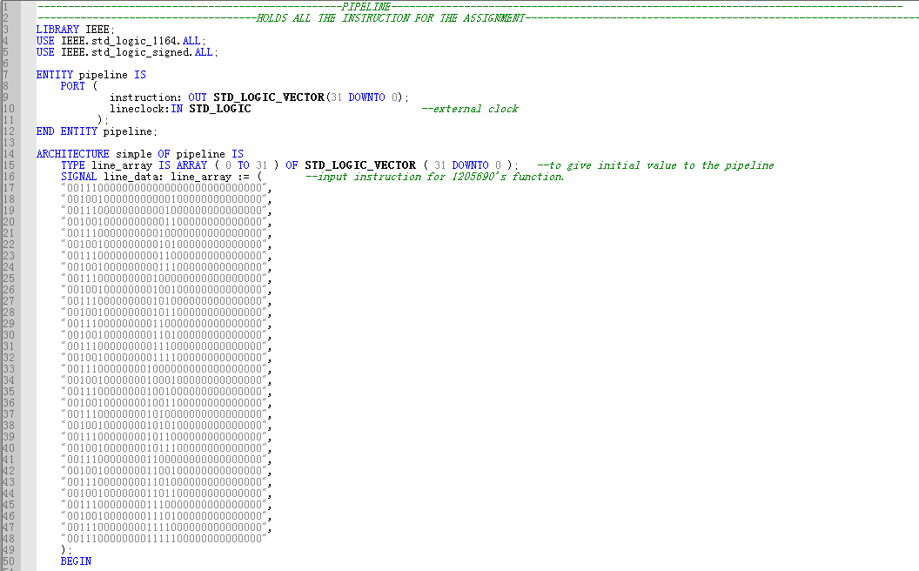
Pipeline-2
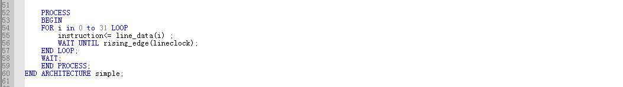
h) Add-delay
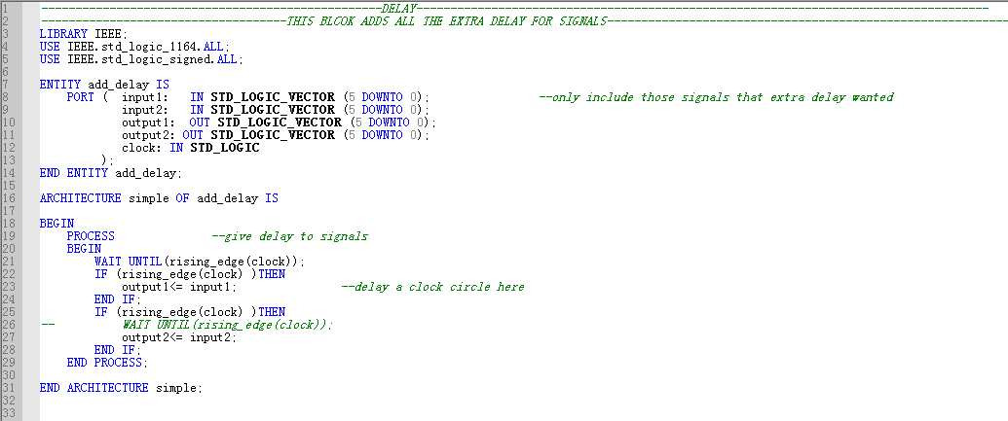
Appendix 2. Simulation Result
After comparing address 1 and 3, g8 decides which signal (the ALU’s current result---mid_data3, or data from the register---mid_data1) goes into the ALU

Data Hazard Solved By Adding No-delay Gate.
The op-code is delayed by one clock cycle to synchronize with the inputs

1.
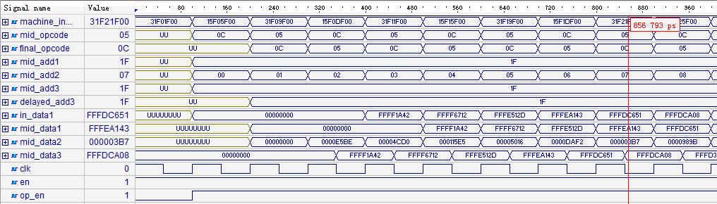
T = 100 NS

Overall enable control

The register is controlled by this enable signal

Note:
- Machine_input: the signal connecting the block “pipeline” and “register”. It is the instruction input of the system
- Mid_op-code & mid_add1-3: the signals coming from register to the next blocks
- Mid_data1&2: the signals coming from the ROM to the next blocks
- In_data: signal coming from the “hazard” block that goes into the ALU
- Mid_data3: the signal/result from the ALU and into the register----this is the result I want.
2.

The instructions come from this signal

How signals flow

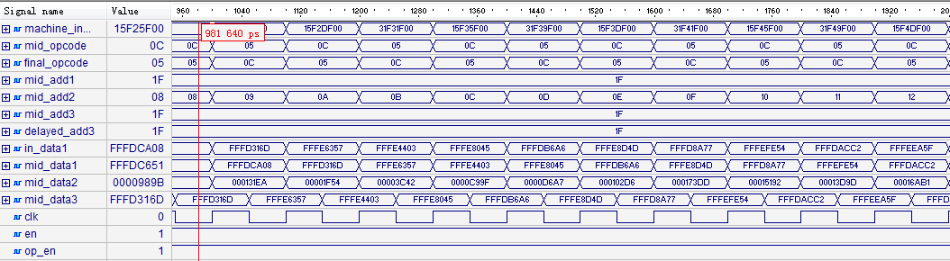
Deliberately delayed 50NS so that the in_data can get the right signal

3&4.
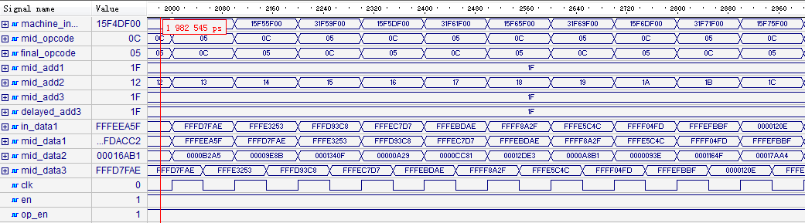
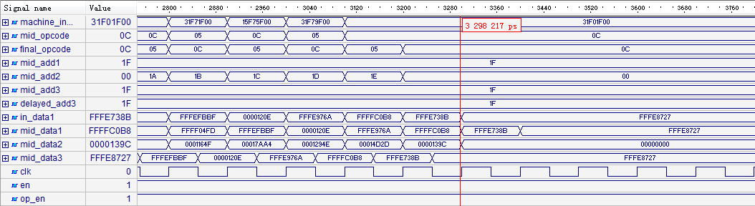
The final result is outputted from ALU at 32ns, written back at 33ns from beginning.

Waveform of Data Hazard Solved By No-ops (result only, op-code and input address still to be altered in later steps)

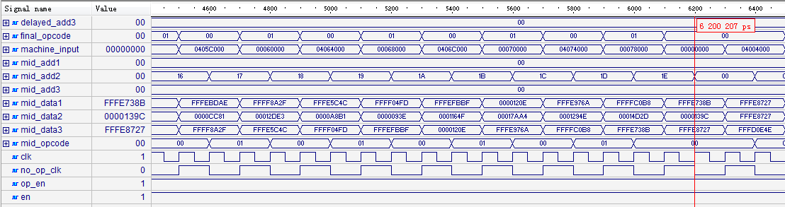
Appendix 3. Individual requirements and result check

My ID number: 1205690

a) ALU control-last digit of ID: 0
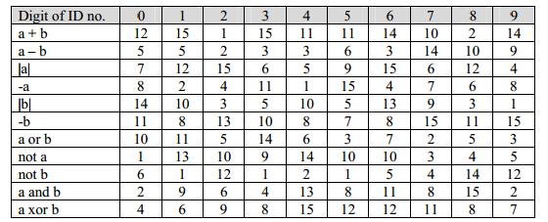

b) Register-last but second digit of ID: 9
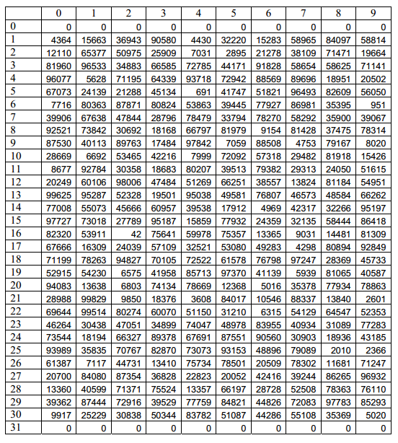

c) Function difference of pipeline
If the third-from-last digit of your student ID is 0, 3, 6 or 9: ID 1205690
The values stored in the even-numbered registers (2, 4, 6 … 30) should be added, and the values in the odd-numbered (1, 3, 5 … 29) registers should be subtracted to form a total that is written into register 31 (i.e. total=-r1+r2-r3+r4-…-r29+r30.) The values of registers 1-30 should not be altered by your program, but the value of registers 0 and/or 31 may be over-written if you wish.

d) Result checking
Address1 | Address2 | Destination register address | Expected DEC value | Expected HEX value | Checked against actual results
R0 | R1 | R31 | -58814 | FFFF1A412 | √
R31 | R2 | R31 | -39150 | FFFF6712 | √
R31 | R3 | R31 | -110291 | FFFE512D | √
R31 | R4 | R31 | -89789 | FFFEA143 | √
R31 | R5 | R31 | -145839 | FFFDC651 | √
R31 | R6 | R31 | -144888 | FFFDCA08 | √
R31 | R7 | R31 | -183955 | FFFD316D | √
R31 | R8 | R31 | -105641 | FFFE6357 | √
R31 | R9 | R31 | -113661 | FFFE4403 | √
R31 | R10 | R31 | -98235 | FFFE8045 | √
R31 | R11 | R31 | -149850 | FFFDB6A6 | √
R31 | R12 | R31 | -94899 | FFFE9D4D | √
R31 | R13 | R31 | -161161 | FFFD8A77 | √
R31 | R14 | R31 | -65964 | FFFEFE54 | √
R31 | R15 | R31 | -152382 | FFFDACC2 | √
R31 | R16 | R31 | -71073 | FFFEEA5F | √
R31 | R17 | R31 | -163822 | FFFD7FAE | √
R31 | R18 | R31 | -118189 | FFFE3253 | √
R31 | R19 | R31 | -158776 | FFFD93C8 | √
R31 | R20 | R31 | -79913 | FFFEC7D7 | √
R31 | R21 | R31 | -82514 | FFFEBDAE | √
R31 | R22 | R31 | -30161 | FFFF8A2F | √
R31 | R23 | R31 | -107444 | FFFE5C4C | √
R31 | R24 | R31 | -64259 | FFFF04FD | √
R31 | R25 | R31 | -66625 | FFFEFBBF | √
R31 | R26 | R31 | 4622 | 0000120E | √
R31 | R27 | R31 | -92310 | FFFE976A | √
R31 | R28 | R31 | -16200 | FFFFC0B8 | √
R31 | R29 | R31 | -101493 | FFFE738B | √
R31 | R30 | R31 | -96473 | FFFF8727 | √
R31 | R0 | R31 | -96473 | FFFF8727 | √
 |  | R31 | -96473 | FFFF8727 | √

